NOS Report

- Student: Issam Awamleh
- Company: JODDB
- URN of NOS: SEMPMO221
- Name of NOS: Contributing to effective team working

**Performance criteria of the NOS and how you applied it in your company **
(Explain and include evidence from your work)
P1 :present yourself in the workplace on time and in a way that does not cause concern to other team members:
I present myself to the team by clarifying my strength points to them for make it easy for them to assigning tasks which suites my experience in the first place and for exploring fields that I really interested in to learn it. And that give me the chance to proof myself also to show them the potential of learning and how I can be useful for the overall flow. With good chance for taking tasks that need research which means new experience and information and skills s new to gain
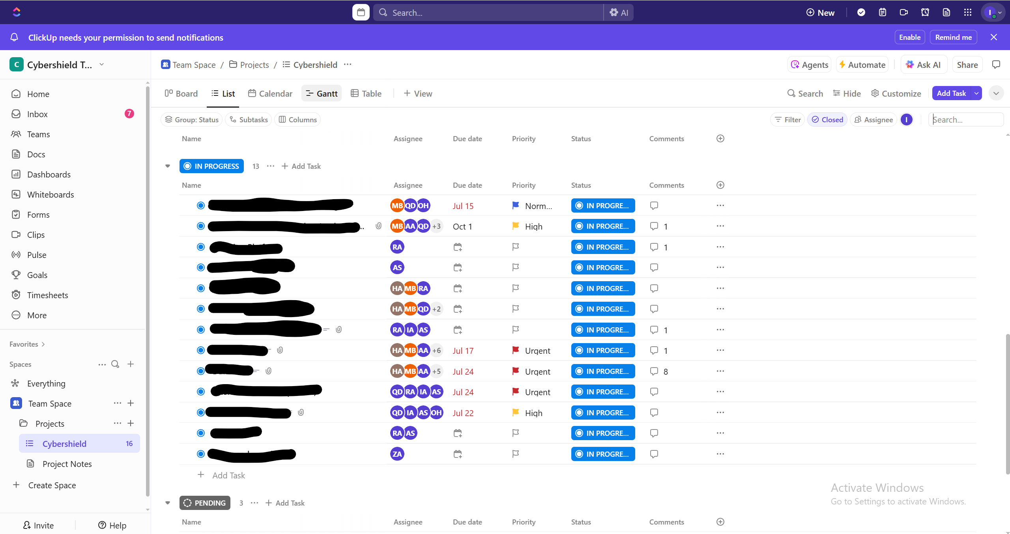
P2: work in accordance with the roles and responsibilities identified for your individual and team activities:
As a trainee in cyber shield I am a part of a team so I’ll be involved in the flow of getting the tasks done regardless if it’s individually or team task the role assigned to the trainee based on their ability and experience of them even in the subtasks as well to achieve the tasks.
P3: make sure that any actions that you take are within the limits of your own responsibility and authority :
I consider my mentor during the tasks as a reference to return to him for getting the input of the tasks and should be clear and understandable to reach the desired output. If any tasks need special permission I also get back to the mentor to make sure I am authorize to make action I usually ask about my permission or limits in the task I take.
P4: ask for information, advice and / or help politely, without causing disruption to your own or other team members work:

I asked for help or information in a break time of my mentors or in their free time (time that they don’t have work to do) and I am careful not to disturb others. If I find them busy I try to find out a way to ask the other trainee who worked on the task previously or I can do research to get the answer of my questions.
P5: offer help to others promptly and willingly in order to ensure team objectives are met:
In some cases when I’m free I offer help to the peers and that to guarantee the to increase the productivity rates. I helped the AI department to get a paid research paper I did it by agreement and as a simple task from my mentor that was one of the cases, I helped other colleagues. I offer to help in a task for Guacamole Server as well.
P6: contribute to team discussion / briefing sessions in a positive manner that shows respect for the views and rights of others:
I attend a TTX meeting to prepare for the scenario and start studying the options based on the storyline and some experience in the cyber security field in that meeting I respect all the opinion that said that meeting subject was a kind of subjective based issue not objective so everyone has an opinion that can said and it was productive meeting that we came out of positive result.

P7: deal with problems in team relationships in ways which minimise offence and maintain mutual respect:
I keep my relationship especially in work with my colleagues professional and out of subjectivity. I face them with the problem in a way of respectful and for the common good of the workflow if there’s no result of facing the problem and the extract the root cause of the problem by having rational conversation I head to the one who is authorized or higher in the hierarchy to find a solution of the problem that we face. That happened to me because unclearness of the input for the tasks I got and with no clear desirable output until the academic monitor from the university find a solution with the high management of cyber shield academy.
P8: refer requests for information and / or assistance that are outside your authority/responsibility to the appropriate people:
And that was obvious that I communicated and get back to the person who’s higher in positions than me to follow the hierarchy of the organization to get to the right person who has the information or authorized to assist me in my tasks. In instance of this case I seldomly contact Ahmad ghniemat(which is the head of the department and the manager of the mentors to know about the input of the tasks whether an information or assistance in a tasks also to get to an output that is conceivable.
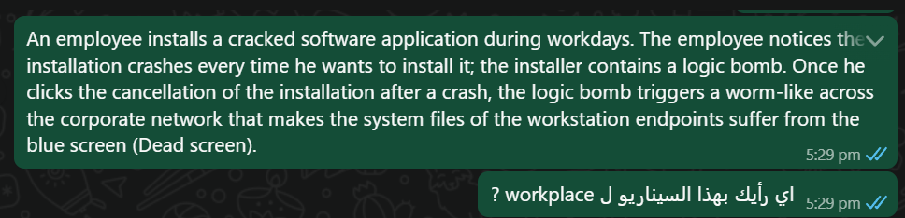
P9: work together to resolve disagreements and difficulties in team relationships:
In this point I was direct with me boss and mentors if there’s disagreement happened I express my point of view in honest ,clear and respectful way if there’s no useful result that can resolve conflict I head to someone who more authorized to resolve it and I take it in objective way and arguing for the common good of the workflow. And there’s so many Teams meeting that has been made between me and the academic advisor in the university and face to face meetings with my work mentors.
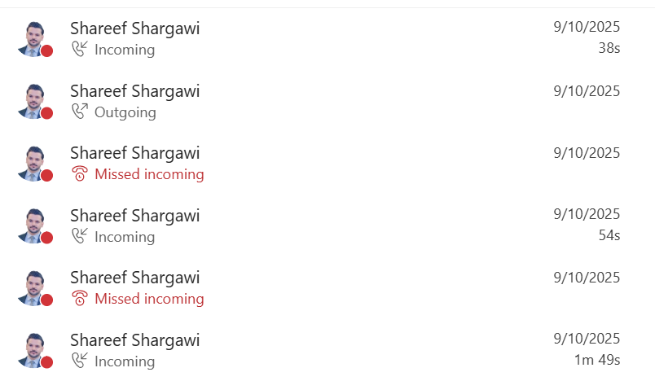
P10: communicate in a manner which promotes understanding, goodwill and trust:
I tried to promote understanding and goodwill and trust by offering my help to the others and to show them that I am trustworthy, especially in work. I n the teamwork tasks I tried to show understanding and compatibility between me and the other by understand their work also show interest to learn from them that give the feeling of trust and compatibility in work sometimes if some colleagues ask for help if I am free immediately I moved to his/her task trying to help or give him/her the resources that they needs. My mentor asked me to format a pc and install some apps in it I was free, and I do it with enthusiasm and eagerness that also reflect understanding and trust.

